LOGING AND TESTING IN PYTHON

Python Logging Basics: How-To Tutorial, Examples & More

Loggin and printing in python: ->

import logging
class Logger(logging.Logger):
def __init__(self, name: str) -> None:
super().__init__(name)
self.setLevel(logging.DEBUG) # creating custom log levels :
self.propagate = False

# Set the custom logger class as the default logger class
logging.setLoggerClass(Logger)

# Use the custom logger
logger = logging.getLogger(__name__)

ERROR LEVELS :
CRITICAL = 50
ERROR = 40
WARNING = 30
INFO = 20
DEBUG = 10
NOTSET = 0

-> Debugging Techniques in Python:->

- Use Tracebacks to identify the source of errors. Carefully read the traceback message to locate the line and type of error in your code. (traceback calls when the execution of the programs fails…)

- Insert print() statements to track variable values and program flow. Place them strategically to understand how data changes at different points in your code.

- Utilize logging for structured debugging. Configure logging levels (e.g., DEBUG, INFO, ERROR) to capture detailed information about program execution.

- Apply try-except blocks to handle exceptions gracefully. Wrap suspicious code in try blocks and catch specific exceptions in except blocks.

- Use assertions to validate assumptions in your code. Add assert statements to check conditions and raise errors if they fail.
    - python -O script.py -> disables all the assert statements.
    - Use assert for:
      - Debugging
      - Internal sanity checks
      - Developer assumptions
    - Use assert to catch the bugs not handles excepted problems.
    - 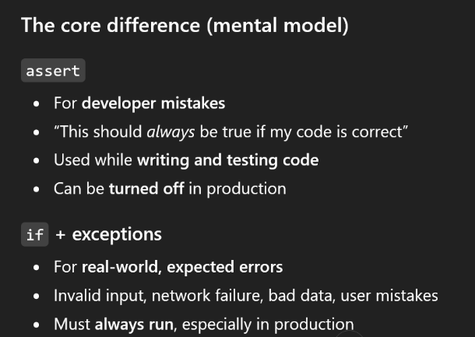

- Leverage the Python Debugger (PDB). Insert pdb.set_trace() or use breakpoint() to pause execution and inspect variables interactively.

- Write unit tests to verify individual components of your code. Use frameworks like unittest or pytest to catch bugs early.

- Set breakpoints in your IDE (e.g., PyCharm, VS Code) to pause execution and step through your code line by line.
  - Theres a debugger In the right left side of the vscode
and you can just use it there.

- Use code linters like pylint or flake8 to identify syntax errors and enforce coding standards.

- Profile your code with tools like cProfile or memory_profiler to identify performance bottlenecks and optimize resource usage.

Python Logging Modules

Pythons logging module :->
  - Lets you build flexible log events.
  - Using logs is better cause the log messages will persist even after you close the program and they are much more detailed.
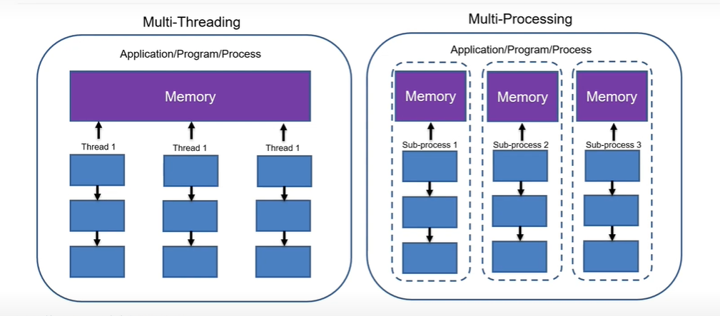

TESTING IN PYTHON

Unit testing :
- test fixture - A test fixture represents the preparation needed to perform one or more tests, and any associated cleanup actions. This may involve, for example, creating temporary or proxy databases, directories, or starting a server process.
- test case - A test case is the individual unit of testing. It checks for a specific response to a particular set of inputs. unittest provides a base class, TestCase, which may be used to create new test cases.
- test suite - A test suite is a collection of test cases, test suites, or both. It is used to aggregate tests that should be executed together.
- test runner - A test runner is a component which orchestrates the execution of tests and provides the outcome to the user. The runner may use a graphical interface, a textual interface, or return a special value to indicate the results of executing the tests.

Using unittest module: inherit unittest.Testcase
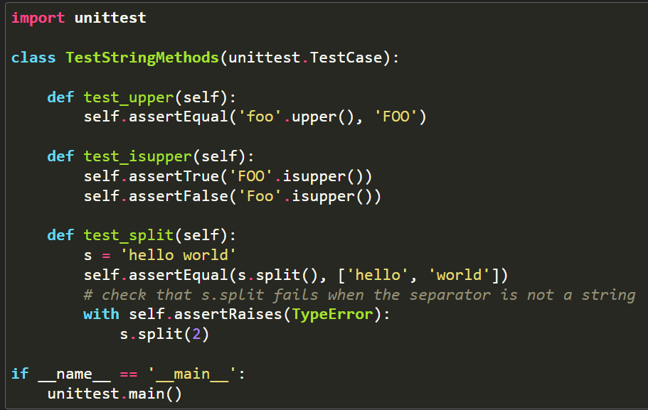
assetEqual() -> asserts expected res to be eqvivalent.
assertTrue() -> verify condition
assertFalse() -> verify condition
assertRaises() -> raises errors
unittest.main() -> provides a command-line interface to the test script.

Py -m unittest {file locations or empty for everytestcase to run indivisually }
The basic building blocks of unit testing are test cases — single scenarios that must be set up and checked for correctness

pytest has a lot of built-in, advanced features that make it easy to perform sophisticated testing:
- Fixtures: Instead of manually setting up and tearing down resources, you can use fixtures to provide setup data, which simplifies your test code.
- Parametrization: With pytest.mark.parametrize, you can easily run a test with multiple sets of input values.
- Assertions: pytest provides more powerful assertion introspection. For example, when an assertion fails, pytest gives you a detailed message showing exactly where the failure occurred.
- Plugins: There is a rich ecosystem of plugins for various features such as HTML reports, coverage, parallel test execution, etc.

Pythonic Code setup ->
- Arrange, or set up, the conditions for the test
- Act by calling some function or method
- Assert that some end condition is true

Just prefix the test_ keyword in whatever code you write and that become a test func for your shit

Dot (.) -> mean that the testcase has been passes
F -> failed
E -> exception has been raised

Assert -> if true , Else raise a AssertionError
Ignore -O in the productions and ignore the all the assertions.

pytest takes a different approach. It leads you toward explicit dependency declarations that are still reusable thanks to the availability of fixtures. pytest fixtures are functions that can create data, test doubles, or initialize system state for the test suite. Any test that wants to use a fixture must explicitly use this fixture function as an argument to the test function, so dependencies are always stated up front:

